Openai with AWS on ai_blind_resume_screener:
Error 1:
Error with Dynamo DB and the region mismatches:
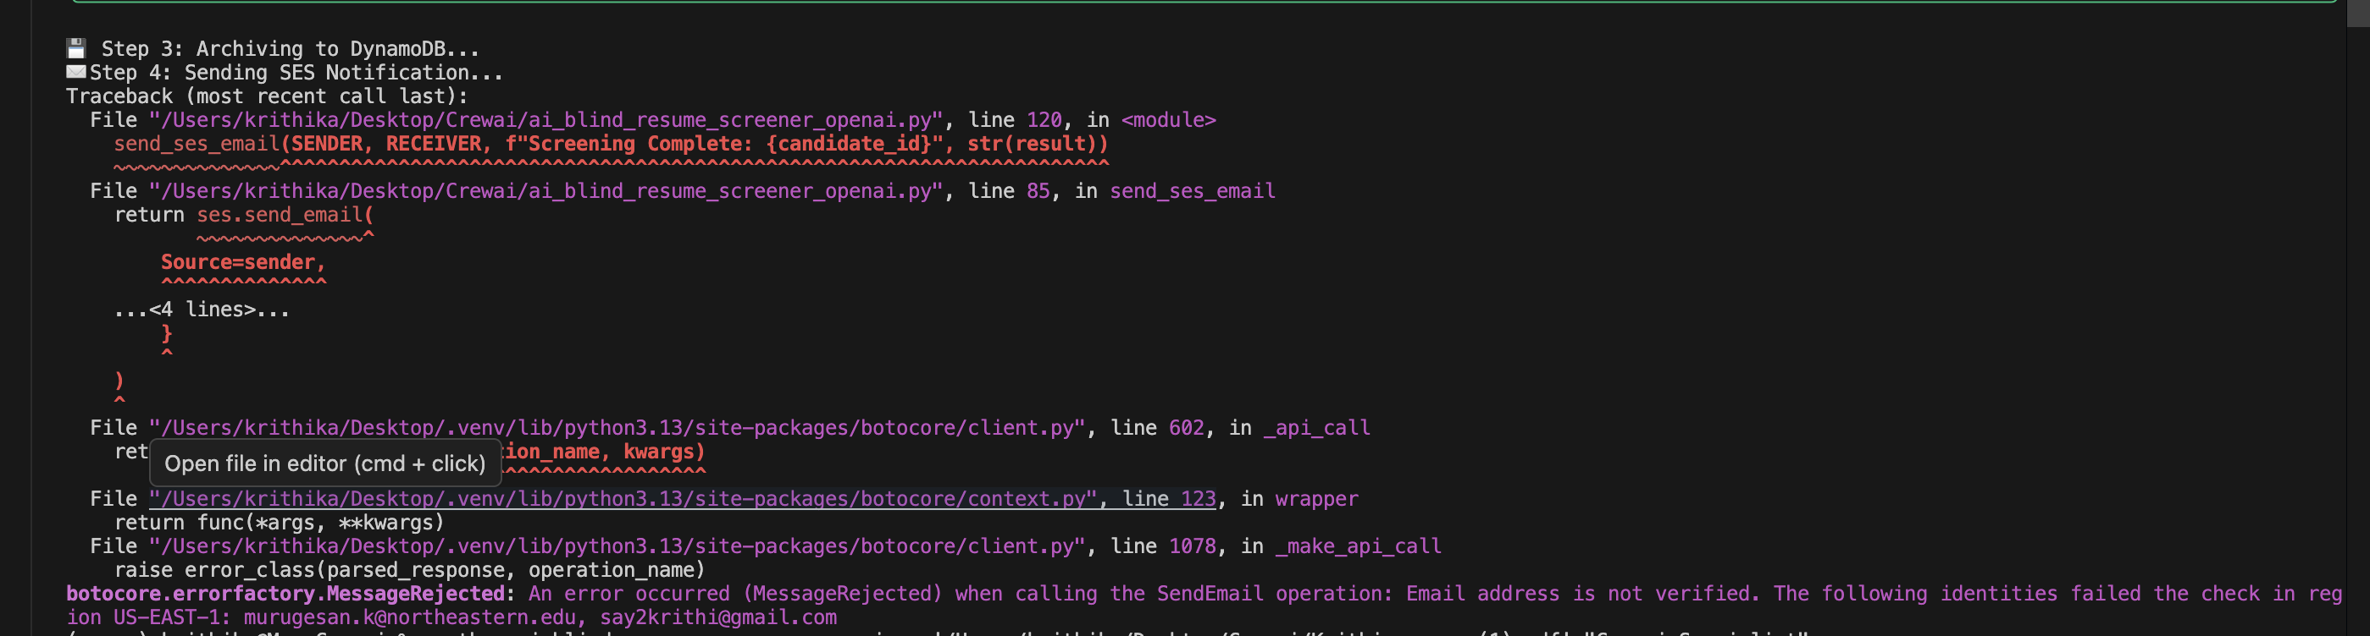
Error 2:
Error with SES email sent : - check for the exact SES location and validate the email in 3 places –spam , sandbox verification and identify case sensitive
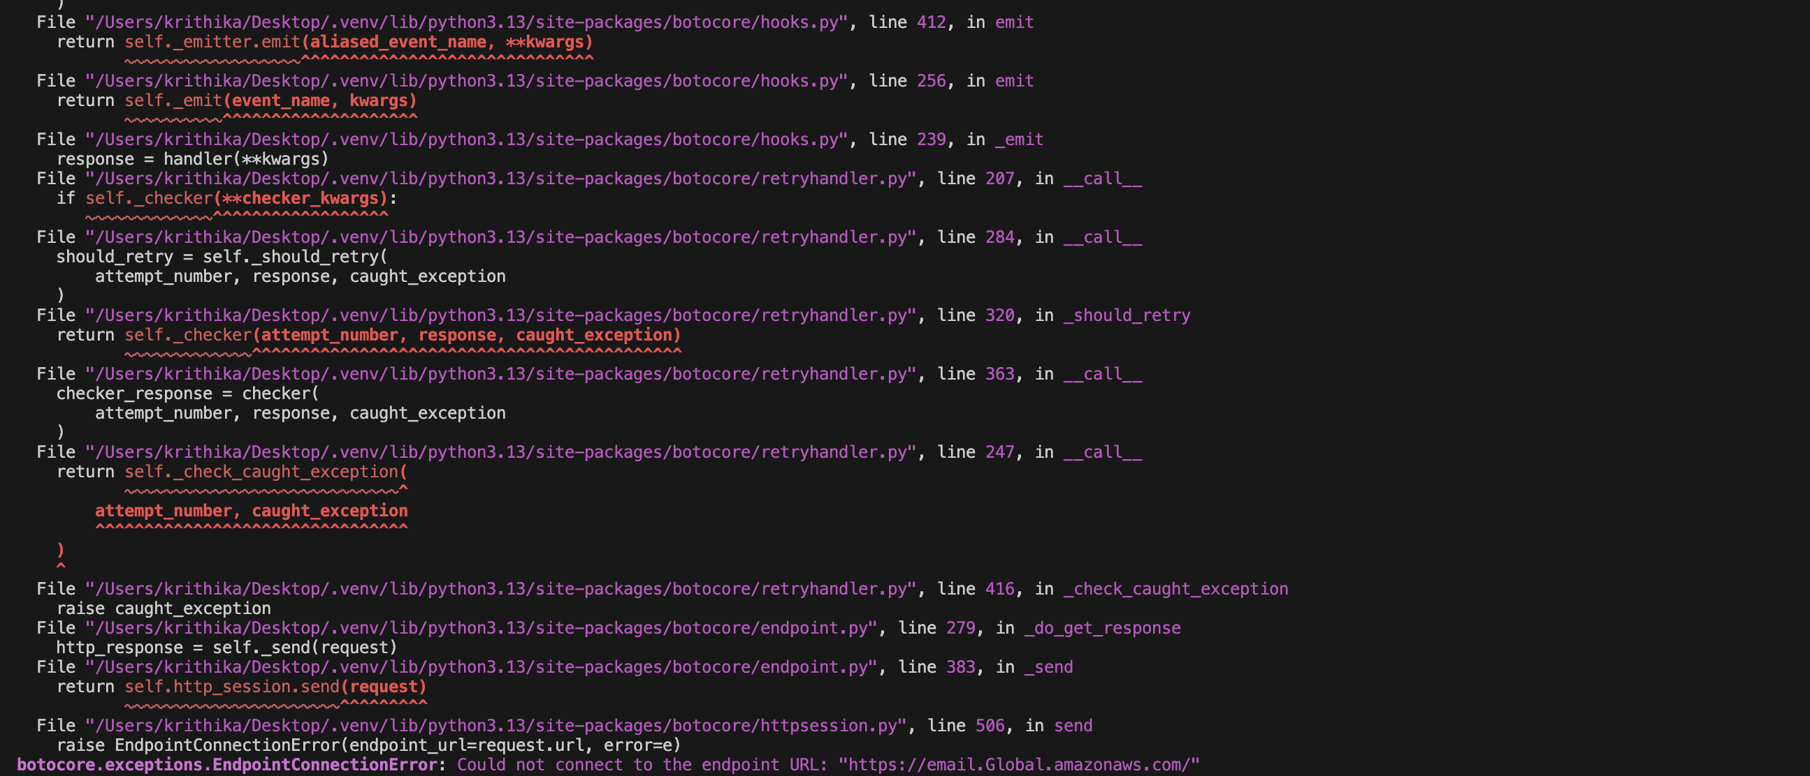
Steps to verify the email after job success :

1. The "Spam" or "Promotions" Folder
It sounds simple, but AWS SES (especially from new accounts) is often flagged by Gmail and Outlook.
- Action: Check your Spam, Junk, and Promotions folders for say2krithi@gmail.com.

2. Sandbox Verification (The "To" Address)
In Sandbox mode, you cannot send emails to any address unless it is also Verified.
- Action: Go to the SES Console > Verified Identities.
- Check: Is say2krithi@gmail.com listed there with a green Verified status?
- Fix: If it is "Pending" or not listed, you must add it and click the verification link in the email AWS sent to that inbox.

3. Identity Case Sensitivity
AWS SES is case-sensitive regarding email addresses. If you verified Say2Krithi@gmail.com (capital S) but your code sends to say2krithi@gmail.com (lowercase s), SES might fail the check silently or reject it after the initial hand-off.
- Action: Ensure the email in your code matches the exact casing shown in the SES Console.
Successful Execution Screenshot :
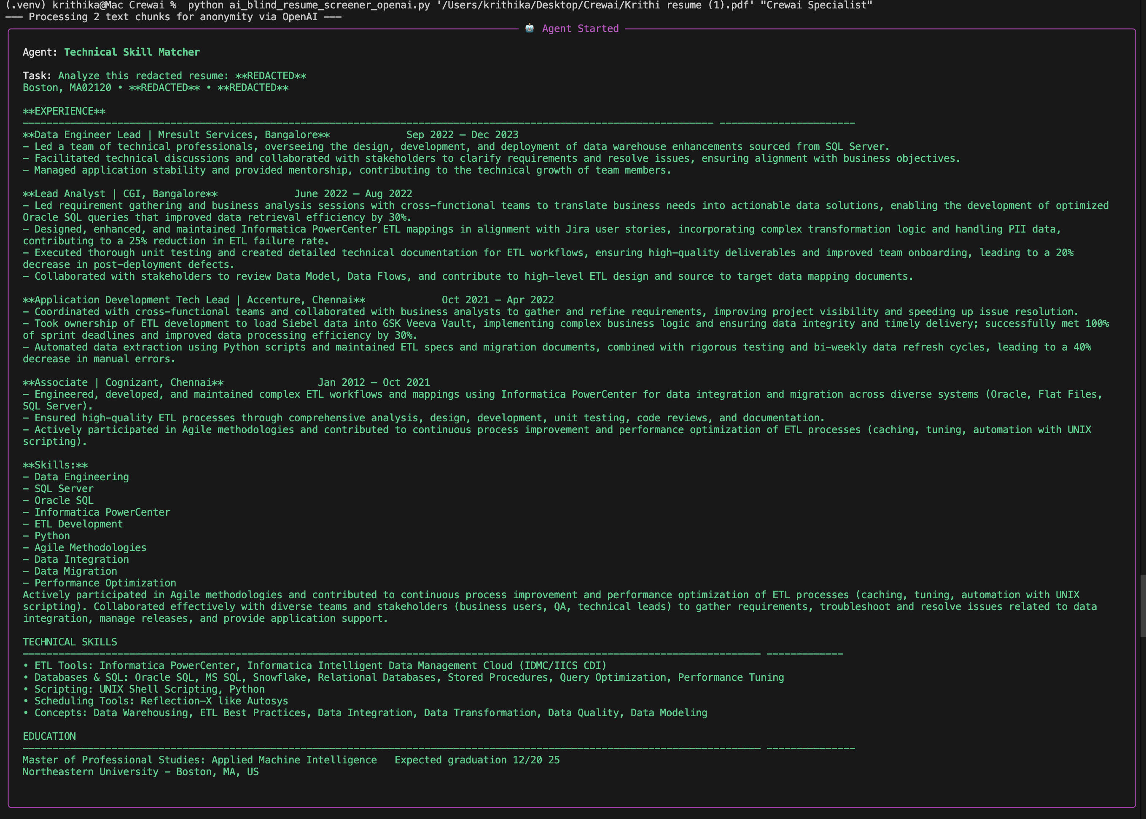
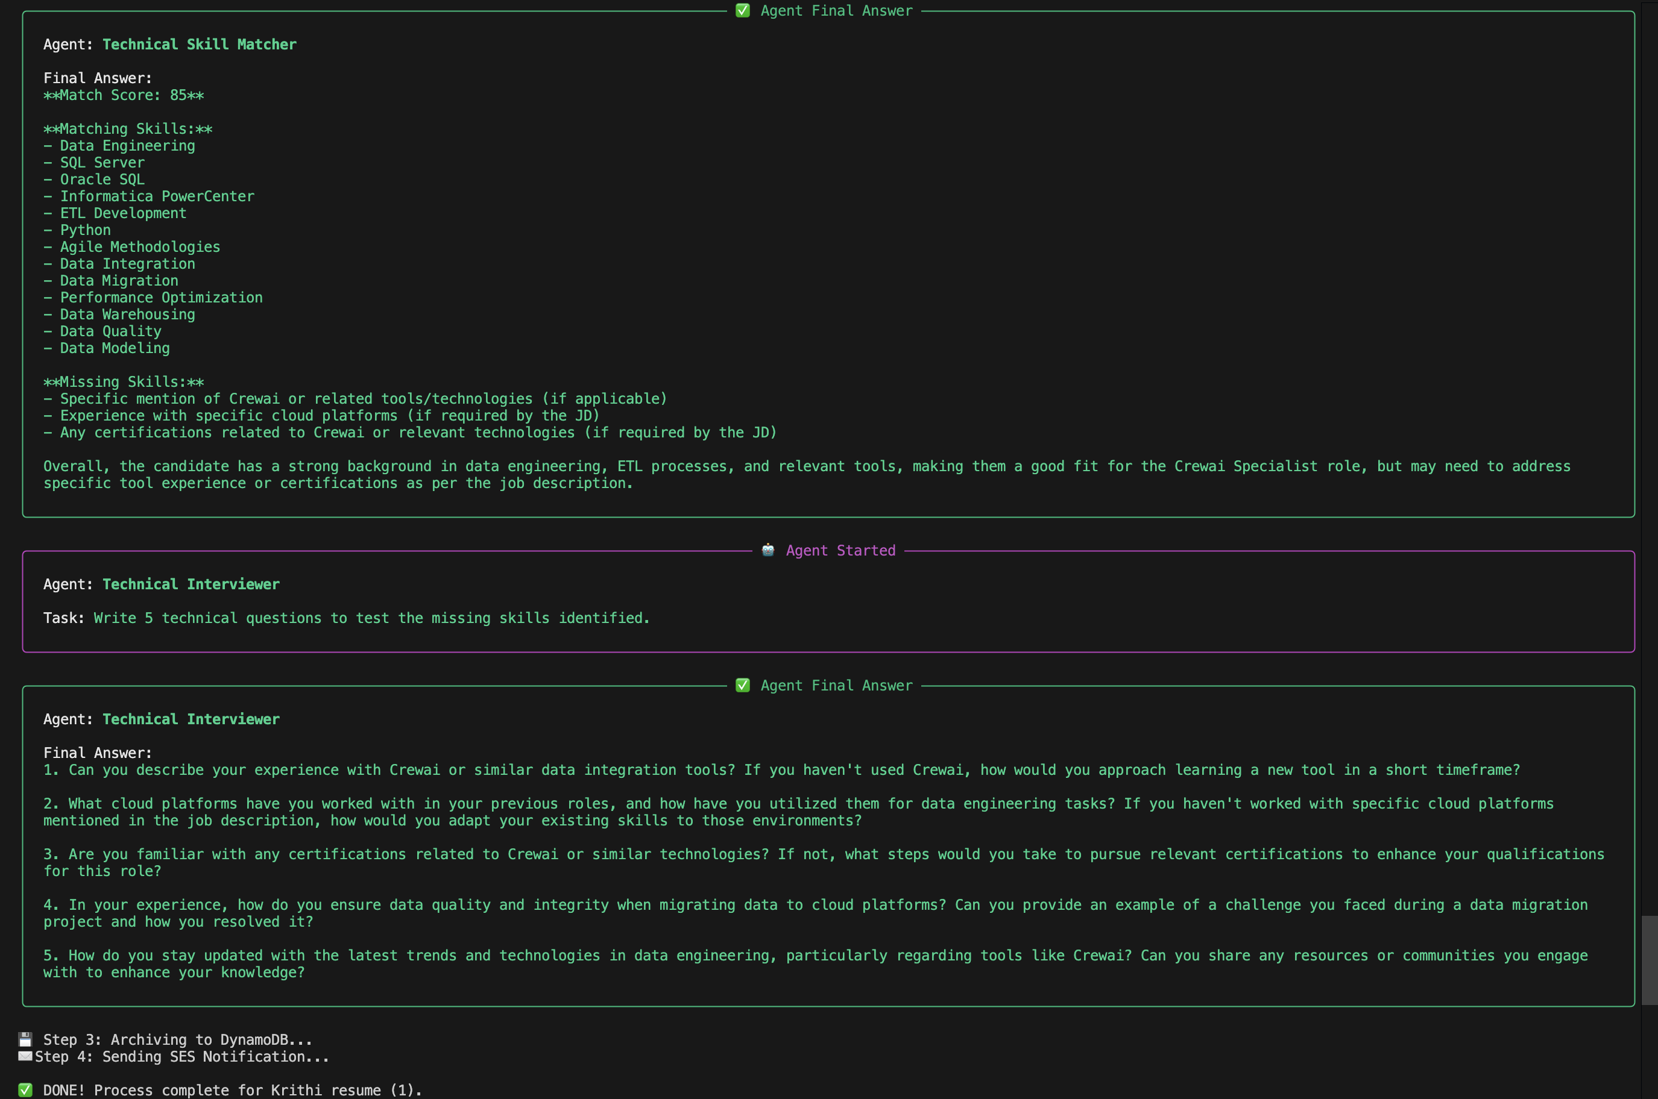
Dynamo DB Screenshot :
